MEDICAL STUDENT PERFORMANCE EVALUATION
Dr. ....

Identifying information

Dr. .... is a graduate of The Hashemite University (HU) Faculty of Medicine in Zarqa, Jordan.

Noteworthy characteristics

- PLEASE SEE THE EXAMPLES BELOW.
SHOULD BE NO MORE THAN THREE POINTS

Academic History:

Date of Initial Matriculation in Medical School: | September 2011
Date of Graduation from Medical School: | May 2017
Extensions, leaves of absence, gaps, breaks in the students’ educational program: | Not applicable
Was the student required to repeat or otherwise remediate any course work during his medical education? If yes, please explain: | Not applicable
Was the student the recipient of any adverse  actions by the medical school or its parent  institution: | No

Academic Progress

Professional performance:
Dr. .... had very fruitful years of study. He demonstrated both the skill and character required of a physician. In addition, his interpersonal skills, ethics and attitude have made him an exceptional student. As a result, he was able to meet all our necessary objective standards required of each student enrolled in our program.

Preclinical/Basic Science Curriculum:

- Premedical courses:
This premedical course consists of several blocks including Basic Sciences, Medical Policies, Medical Economics, and Ethics that extended over the course of the first year.
Dr. .... successfully completed the required premedical coursework with an average of (XX/4.00).
- Pre-clinical courses:
These courses consisted of two years of extensive basic medical sciences, divided into lecture classes as well as laboratory classes.
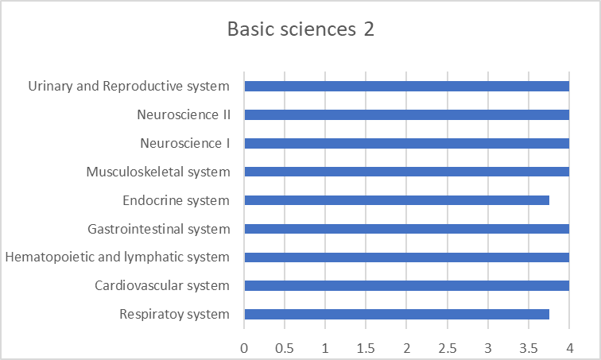
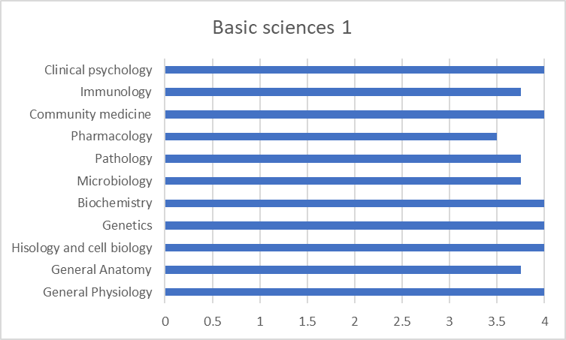
Dr. .... was able to successfully complete the course with an average of (XX/4.00) in the second year and (XX/4.00) in his third year.
USING EXCEL, MAKE A SIMPLE CHART LIKE THE ONE HERE SHOWING YOUR CLERKSHIP GRADE.

Clinical clerkships:
The student’s grade in each of the courses during his fourth and fifth years is the sum of three components:
- In-course evaluation (20%); students are evaluated by the attending physician based on his performance and his attitude during the course.
- End-of-rotation OSCE (40%)
- Final written exam (40%); MCQ exam held once at the end of each academic year, which covers the theoretical aspects of the course.
- Similar rules are applied to the 6th year with the exception of end-of-rotation OSCE (30%) and an additional oral exam of (10%).
The final assessment is categorized numeric categories as shown in the table below:
Rating | Grade | Point
Excellent | A+ | 4.00
 | A | 3.75
 | A- | 3.50

Rating | Grade | Point
Very Good | B+ | 3.25
 | B | 3.00

Rating | Grade | Point
Good | B- | 2.75
 | C+ | 2.50

Rating | Grade | Point
Pass | C | 2.25
 | C- | 2.00
 | D+ | 1.75
 | D | 1.5

Note that the minimum grade required to pass a single subject is D (1.5), while the minimum semester cumulative average to pass is C- (2.00).

The subjects are divided into:
- Four majors: which include internal medicine, surgery, pediatrics, obstetrics and gynecology,
- Thirteen minors: that include psychiatry, neurology and all the other subjects listed in the chart below.

Internal Medicine Clerkship:
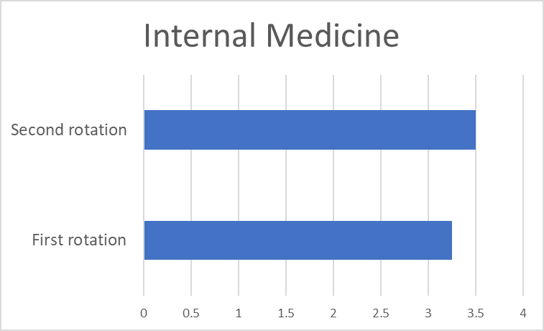
A total of 4 months, two of which were during the first clinical year and two during the last clinical year.
PLEASE SEE THE EXAMPLES BELOW.
ALSO USING EXCEL, MAKE A SIMPLE CHART LIKE THE ONE HERE SHOWING YOUR CLERKSHIP GRADE.

Pediatrics Clerkship:
A total of 4 months, two of which were during the second clinical year and two during the third and last clinical year.
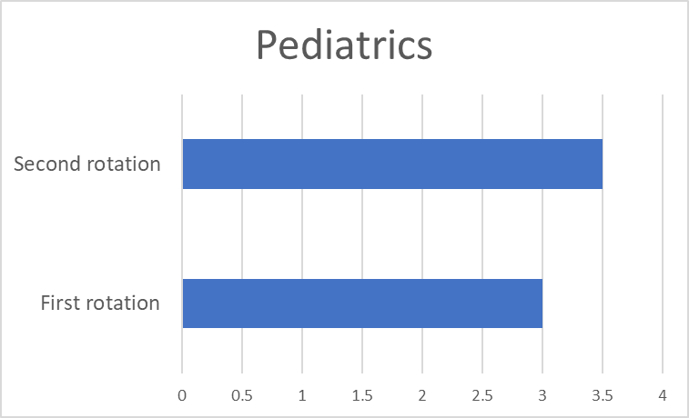
PLEASE SEE THE EXAMPLES BELOW.
ALSO USING EXCEL, MAKE A SIMPLE CHART LIKE THE ONE HERE SHOWING YOUR CLERKSHIP GRADE.

Surgery:
A total of 4 months, two of which were during the first clinical year and two during the last clinical year.
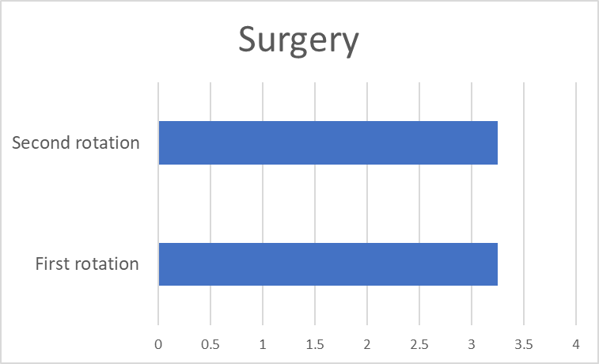
PLEASE SEE THE EXAMPLES BELOW.
ALSO USING EXCEL, MAKE A SIMPLE CHART LIKE THE ONE HERE SHOWING YOUR CLERKSHIP GRADE.

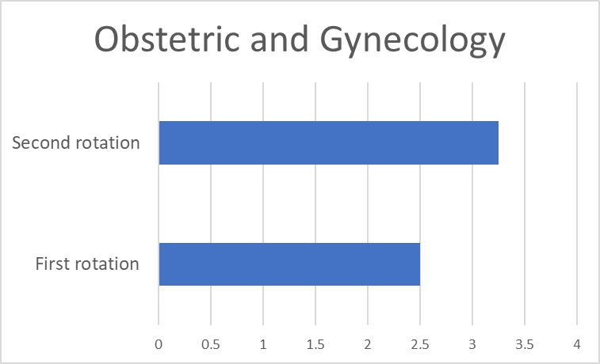
Obstetrics and Gynecology:
A total of 4 months, two of which were during the second clinical year and two during the last clinical year.
PLEASE SEE THE EXAMPLES BELOW.
ALSO USING EXCEL, MAKE A SIMPLE CHART LIKE THE ONE HERE SHOWING YOUR CLERKSHIP GRADE.

Minors: Dr. .... successfully completed the required minor courses with the average for each given in the following chart: USING EXCEL, MAKE A SIMPLE CHART LIKE THE ONE HERE SHOWING YOUR MINORS GRADES.

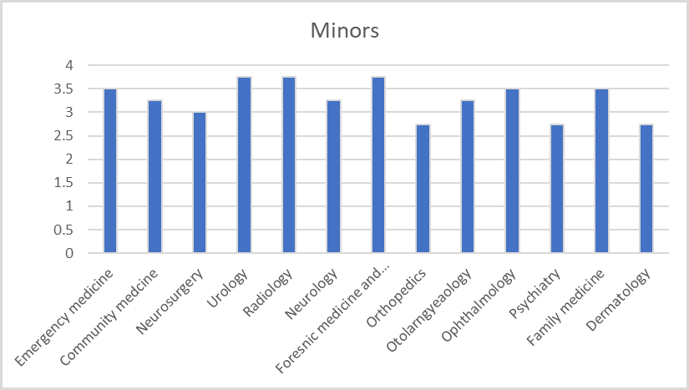
Summary:

Based on our assigned categorization for the final assessment of our graduates, Dr. .... has graduated on the Deans Honor List with an “Excellent” evaluation, ranking in the 95th percentile compared to his peers.
This categorization is based on the final grade of each graduate which includes all his/her grades during the six years. The categories are distributed as the following:

Excellent – Honor: 95th-100th percentile | Very Good: 65th-94th percentile
Good: 30th-64th percentile | Pass: <30th percentile

Dr. .... is a remarkable student who was always engaging in the learning process. Stemming from his outstanding ability to deal with patients and his desire to excel, we truly believe that he’ll grow up to be an amazing physician and we strongly recommend him for a position in your program.

Please contact us if you need any further information about this applicant.

Sincerely,
Prof. Darwish Badran
Dean, Faculty of Medicine
The Hashemite University
E-mail: med@hu.edu.jo

Medical School Information:

Our goals and missions:
The goal of the HU medical school is to cultivate thriving students who seek to expand their knowledge and strive to achieve their leadership role in the society. It’s our firm belief that clinical-based medical education, research and honing superior clinical skills is the framework to fulfill our mission. Stemming from this belief, we were able to direct our efforts to establish a cutting-edge clinical skills education and training center (CSETC), which is one of the most advanced medical laboratories in the Middle East.
In addition, our unrelenting efforts to provide the local community of Az-Zarqa district with quality healthcare is translated through continuous collaborations between our alumni and local health systems.
Our true understanding of diversity being a crucial key to success is reflected by diverse student enrolment from a variety of national and international backgrounds.

Special characteristics of the medical schools’ educational program:
Our educational program consists of 3 phases given over 6 years. Phase 1 is the premedical course given over the first year. Phase 2 is the preclinical course given over the 2nd and 3rd year. Phase 3 is the clinical course and is given over the last 3 years (the details of each course is described in the previous pages). This is conducted with several affiliated hospitals including: Prince Hamza Hospital – the main clinical training site, Hussein Medical Center, Al-Bashir Hospital, Zarqa Governmental Hospital, Prince Hashim Military hospital, and Istiklal Hospital.

Description of the evaluation system used at the medical school:
Premedical and Preclinical courses through phases 1 and 2 are graded based on course performance, attitude and an end of course exam. On the other hand, the clinical clerkships during the 3rd phase are graded-based on performance and attendance (20%), end-of-rotation OSCE (40%) and a final written exam (40%). An additional oral exam is conducted at the end the last year. The grading system is as described previously.
- Average length of enrollment of students in this graduating class, from initial matriculation until graduation: within six years of admission.
- The HU medical school does NOT require that student pass USMLE step 1 or step 2 in order to fulfill graduation requirements.
- The HU medical school requires successful passing of end of rotation exams and Objective Structured Clinical Evaluations (OSCE) covering all clerkship rotations for graduation.
- Information about the medical school’s compliance with the AAMC “Guidelines for Medical Schools Regarding Academic Transcripts”
- Each MSPE is written by one of three physician deans at the Associate or Assistant level.
- The narrative comments in the MSPE are reported exactly as written, with corrections made to reflect proper punctuation, grammar, and spelling.
- Students are permitted to review his/her MSPE prior to transmission.
- The HU medical school does NOT follow the AAMC “Guidelines for Medical Schools Regarding Academic Transcripts.”

Please note that the MSPE should not exceed 7 pages.
Also, make sure that the “noteworthy characteristics” and “clerkships” sections include your personal achievements and experience as this is very important for the US residency programs.
The links provided below will assist you in the writing process.
Link 1: https://www.feinberg.northwestern.edu/md-education/docs/current-students/Sample-MSPE-2017.pdf
Link 2: https://www.ohsu.edu/xd/education/schools/school-of-medicine/academic-programs/md-program/student-affairs/upload/Jane-Doe-outstanding-2.pdf

Link 3: https://smhs.gwu.edu/advising/sites/advising/files/sample%20MSPE.edited%20%281%29.pdf

Link 4: https://www.aucmed.edu/content/dam/dmi/www_aucmed_edu/PDFs/ospd/MSPE-Sample-(2).pdf

Link 5: https://depts.washington.edu/fammed/wp-content/uploads/2017/10/MSPE-Example-File-2018.pdf
For further information, please check the AAMC link: https://www.aamc.org/download/470400/data/mspe-recommendations.pdf

